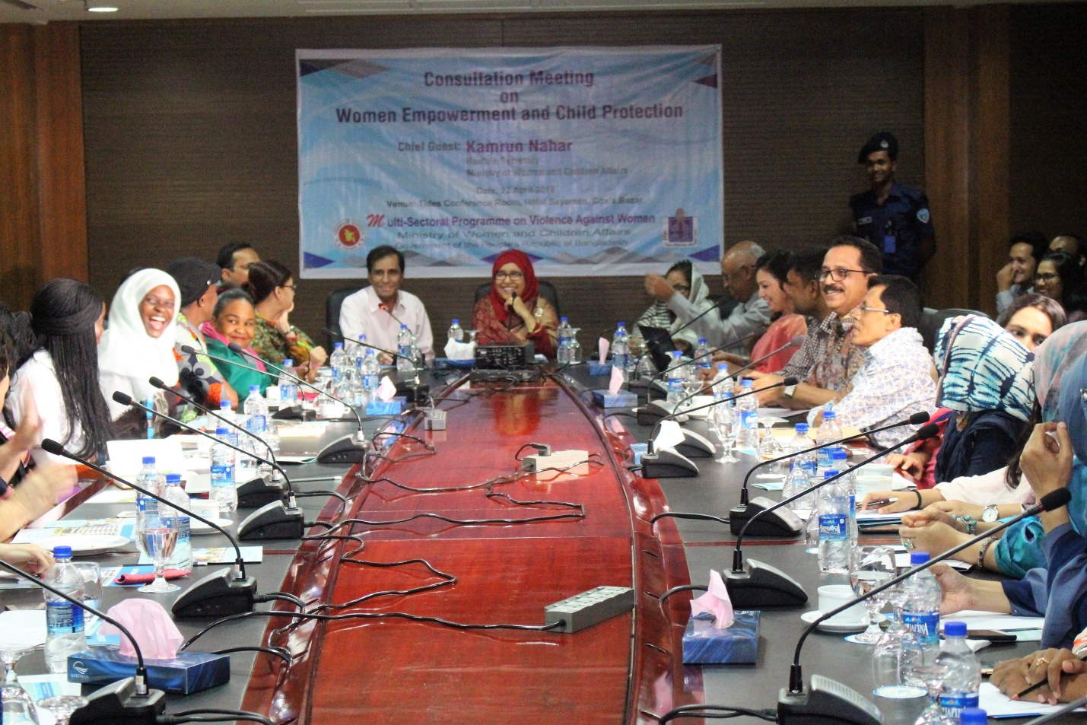
- Consultation Meeting on Women Empowerment and Child Protection:

A consultation meeting on Women Empowerment and Child Protection was held on 22 April 2019 at Hotel Sayeman, Cox’s Bazar under the Multi-Sectoral Programme on Violence Against Women of the Ministry of Women and Children Affairs. Hon’ble Secretary of the Ministry of Women and Children Affairs Kamrun Nahar was present as chief guest in meeting. The Commissioner of the RRRC Mohammad Abul Kalam ndc was also present in the meeting. Different stakeholders from Government, Non-Government Organizations, and Development Partners works on Rohingya people were present in the meeting. Hon’ble Secretary in her speech said that government is providing shelter and food for humanitarian need. She added that other actors are also supporting Government in some ways. She also emphasized that women empowerment is important, but it is also necessary to ensure their health, food, rights and dignity, and livelihood activities and to reduce vulnerability.

