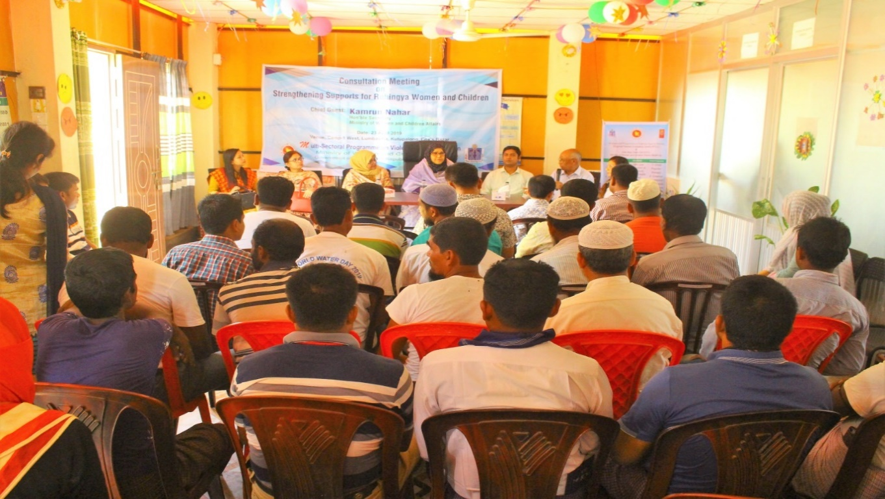
- Consultation Meeting on Strengthening Supports for Rohingya Women and Children :A consultation meeting on strengthening supports for Rohingya Women and children was held on 23 April 2019 at the Regional Trauma Counseling Centre (RTCC), Camp 1 west, Lambashia, Kutupalong. Hon’ble Secretary of the Ministry of Women and Children Affairs KamrunNahar was present as chief guest. Different professionals of the RTCC, OCC, Rohingya head majhi, side majhi, religious leaders were present and shared their experiences.

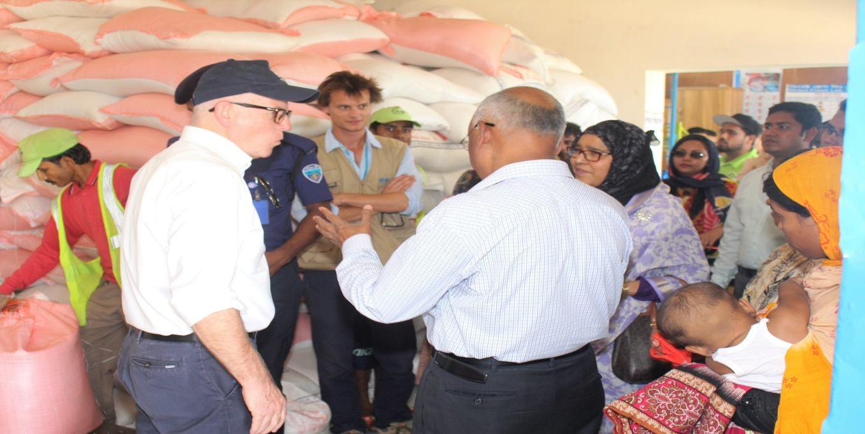
- Visits different Programmes: Honorable Secretary visited E-Voucher Assistance Outlet, WFP distribution point, camp 2 west, Extension. WFP staffs briefly describe their activities for the Rohingya.

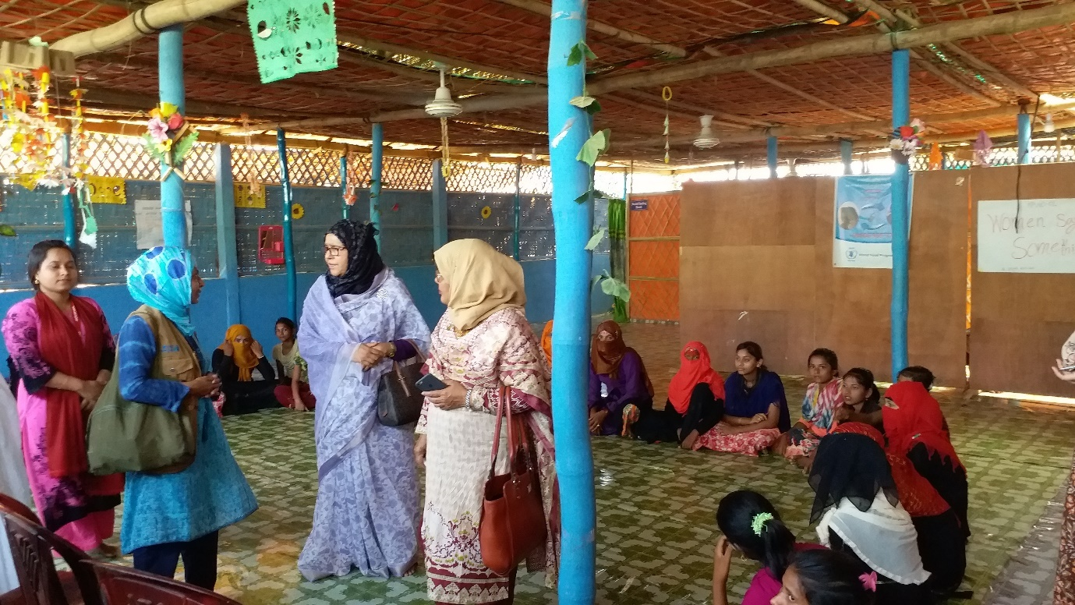
She also visited the Women Friendly Space of UNFPA, implemented byMukti Cox’s Bazar in Camp 1 west and Multi-Purpose Centre of UN Women in Camp

At last she visited the Hope foundation Hospital, Camp 4, there she observed the OT, Pediatric and Neonate Unit and other health facilities for the Rohingya community.
